
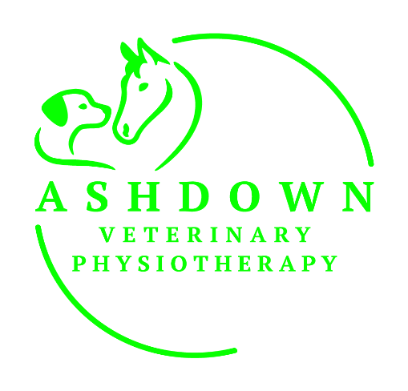 OWNER’S REGISTRATION and CONSENT FORM

Owner Details
Name
Address

Email
Phone

Animal Details
Name |  | Breed
Age (DoB) |  | Colour
Insured? | YES NO | Insurance Company

Please describe and detail your animal’s current complaint/condition and difficulties
Briefly describe/list of any previous medical history/conditions/problems including any scans/investigations
Please list all current medications and dietery supplements (long term and/or temporary)
Safety and your pet’s mental, as well as physical wellbeing, is my top priority! Please detail any handling or behavioural issues you think your pet may be concerned about with a stranger being in close proximity in their home/stable. (Eg. Wears a muzzle at the vets/groomers/having nails clipped/ has noise sensitivity / does not like being touched etc).
Horse Owners only
Yard Address

Please Select | Mare Gelding Stallion
Height |  | Discipline  (If relevant) |  | Level
Dog/Cat Owners only
Please select | Male Female Neutered Entire
Weight |  | Sporting Discipline |  | Level

To provide the best of care for your pet I will need to ask your vet for their clinical history, and I may need to discuss their management with your vet and other associated professionals.
Vet Details
Vet’s Name |  | Surgeon’s Name
Practice Name |  | Specialist Referral  Centre
Practice Address |  | Address
Practice Email |  | Email

Consent
I agree to ACE Vet Physio assessing and treating my pet and communicating with my vet and other professionals as appropriate, for optimum provision of care.
I agree ACE Vet Physio may require use of photographs or video of my pet in relation to training and development or discussing appropriate management of care for my pet with other relevant professionals. Promotional use (i.e. social media) is optional Yes/NO (please circle).
Please return as soon as possible to zoemorton@ashdownvetphysio.uk to ensure enough time before your first appointment to request the mandatory consent from the appropriate vet.
SIGNED (electronic signature is acceptable) PRINT NAME
Date
This form collects your details so that we can provide our service to you. Please visit my website at Ashdownveterinaryphysiotherapy.co.uk to view our Privacy Policy for information about how we store, protect, and manage your data.

