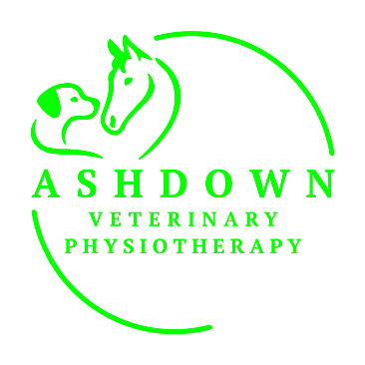
VETERINARY PHYSIOTHERAPY CONSENT FORM

This form is intended to gain veterinary consent for a specific targeted diagnosis or condition, that has already been assessed and deemed appropriate for physiotherapy by a veterinary surgeon/specialist. Direct contact will be made for any changes requiring veterinary check.
Owner Details
Name
Address
Telephone |  | Email
Animal Details
Name |  |  | Breed
Sex |  |  | Age
Current  Diagnosis  Contraindications |  | (Please amend/update/add details as required)
Medication

Investigations

Pre-existing Conditions

I consent to this animal having physiotherapy assessment and treatment for the described current diagnosis:
Vet Practice
Telephone |  | Email
Vet’s Name
Vet’s Signature |  |  |  | Date

Would you like to receive a report after initial assessment YES/NO
Please return the signed consent form and complete past medical history to: zoemorton@ashdownvetphysio.uk
Many Thanks



